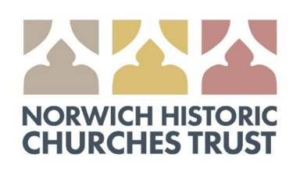

Boost your donation by 25p for every £1 you donate using Gift Aid
Thank you for making a donation to Norwich Historic Churches Trust (charity no. 266686). To help us claim gift-aid please fill in the form below.
☐ I want to Gift Aid my donation of £ Enter amount.
☐ I would like to Gift Aid any donations I make in the future or have made in the past 4 years to Norwich Historic Churches Trust
I am a UK taxpayer and understand that if I pay less Income Tax and/or Capital Gains Tax in the current text year than the amount of Gift Aid claimed on all my donations it is my responsibility to pay and difference.
My details:
Title First names or initial(s)
Surname
Home address
Postcode
Email
☐ Tick here if you would like to join our mailing list
Date
Please notify Norwich Historic Churches Trust if you:
- Want to cancel this declaration
- Change your name or home address
- No longer pay sufficient tax on your income and/ or capital gains
Return this form to: info@norwich-churches.org or
St Martin at Palace Church, 15 St Martin at Palace Plain, Norwich, NR3 1RW

